SESSION LAYER

1.0 INTRODUCTION
The session layer resides above the transport layer and provides “value added” services to the underlying transport layer services. The session layer (along with the presentation layer) add services to the transport layer that are likely to be of use to applications, so that each application doesn’t have to provide its own implementation. It is the thinnest layer in the OSI model. At the time the model was formulated, it was not clear that a session layer was needed.
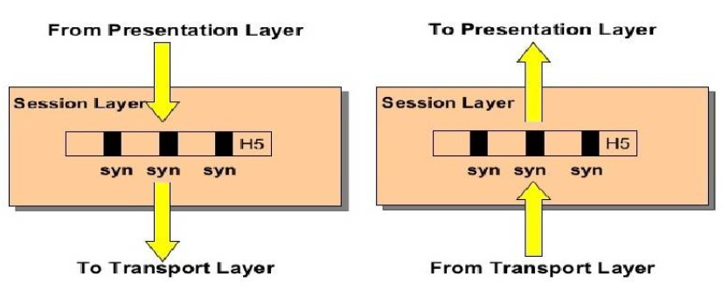
Figure x. Session Layer in the OSI model

2.0 FUNCTIONS
The session layer provides the following services.
1. Dialog management:
Deciding whose turn it is to talk. Some applications operate in half-duplex mode, whereby the two sides alternate between sending and receiving messages, and never send data simultaneously. In the ISO protocols, dialog management is implemented through the use of a data token. The token is sent back and forth, and a user may transmit only when it possesses the token.
2. Synchronization:
The transport layer handles only communication errors, synchronization deals with upper layer errors. In a file transfer, for instance, the transport layer might deliver data correctly, but the application layer might be unable to write the file because the file system is full.
Users can split the data stream into pages, inserting synchronization points between each page. When an error occurs, the receiver can resynchronize the state of the session to a previous synchronization point. This requires that the sender hold data as long as may be needed.
Synchronization is achieved through the use of sequence numbers. The ISO protocols provide both major and minor synchronization points. When resynchronizing, one can only go back as far as the previous major synchronization point. In addition, major synchronization points are acknowledged through explicit messages (making their use expensive). In contrast, minor synchronization points are just markers.
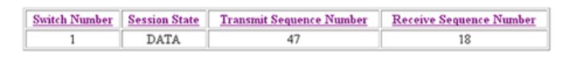
Figure x. Example of session layer diagnostics
3. Activity management
Allow the user to delimit data into logical units called activities. Each activity is independent of activities that come before and after it, and an activity can be processed on its own.
Activities might be used to delimit files of a multi-file transfer. Activities are also used for quarantining, collecting all the messages of a multi-message exchange together before processing them. The receiving application would begin processing messages only after all the messages had arrived. This provides a way of helping insure that all or none of a set of operations are performed. For example, a bank transaction may consist of locking a record, updating a value, and then unlocking the record. If an application processed the first operation, but never received the remaining operations (due to client or network failures), the record would remain locked forever. Quarantining addresses this problem.

4. Exception handling
A General purpose mechanism for reporting errors.

