TCP/IP AND THE OSI MODEL
1.0 INTRODUCTION
The networking industry has a standard seven-layer model for network protocol architecture called the Open Systems Interconnection (OSI) model. The OSI model represents an effort by the International Organization for Standardization (ISO), an international standards organization, to standardize the design of network protocol systems to promote interconnectivity and open access to protocol standards for software developers.
2.0 OSI MODEL
The OSI Model is a logical and conceptual model that defines network communication used by systems open to interconnection and communication with other systems. The Open System Interconnection (OSI Model) also defines a logical network and describes computer packet transfer by using various layers of protocols.
The characteristics of the OSI model are as follows.
- A layer should only be created where the definite levels of abstraction are needed.
- The function of each layer should be selected as per the internationally standardized protocols.
- The number of layers should be large so that separate functions should not be put in the same layer. At the same time, it should be small enough so that architecture doesn't become very complicated.
- Each layer relies on the next lower layer to perform primitive functions. Every level should able to provide services to the next higher layer
- Changes made in one layer should not need changes in other lavers.
The OSI model is important because
- it helps one to understand communication over a network;
- Troubleshooting is easier due to separation of functions into different network layers;
- It helps users to understand new technologies as they are developed.
- It allows users to compare primary functional relationships on various network layers.
2.1 History Of OSI Model
Here are some important landmarks from the history of the OSI model:
- In the late 1970s, the ISO conducted a program to develop general standards and methods of networking.
- In 1973, an Experimental Packet Switched System in the UK identified the requirement for defining the higher-level protocols.
- In the year 1983, the OSI model was initially intended to be a detailed specification of actual interfaces.
- In 1984, the OSI architecture was formally adopted by ISO as an international standard.
2.2 OSI Model Layers
OSI model is a layered server architecture system in which each layer is defined according to a specific function to perform. All these seven layers work collaboratively to transmit the data from one layer to another.
The Upper Layers deal with application issues and mostly implemented only in software. The highest is closest to the end system user. In this layer, communication from one end-user to another begins by using the interaction between the application layer. It will process all the way to end-user.
The Lower Layers handle activities related to data transport. The physical layer and datalink layers also implemented in software and hardware.
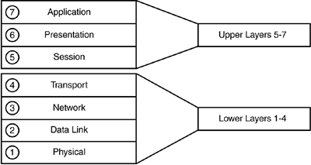
Figure 1 OSI years
Layer 1: Physical Layer
The physical layer is responsible for the transmission and reception of raw data between a device and a physical transmission medium. It converts the digital bits into electrical, radio, or optical signals. Layer specifications define characteristics such as
- voltage levels,
- the timing of voltage changes,
- physical data rates,
- maximum transmission distances,
- modulation scheme,
- channel access method, and
- physical connectors.

Layer 2: Data Link Layer
The data link layer provides node-to-node data transfer—a link between two directly connected nodes. It detects and possibly corrects errors that may occur in the physical layer. It defines the protocol to establish and terminate a connection between two physically connected devices. It also defines the protocol for flow control between them.
The data link layer in IEEE 802 is divide into two sublayers, i.e
- Medium access control (MAC) layer – responsible for controlling how devices in a network gain access to a medium and permission to transmit data.
- Logical link control (LLC) layer – responsible for identifying and encapsulating network layer protocols, and controls error checking and frame synchronization.
IEEE 802 networks such as 802.3 Ethernet, 802.11 Wi-Fi, and 802.15.4 ZigBee operate at the data link layer.
Layer 3: Network Layer
The network layer provides the functional and procedural means of transferring variable length data sequences (called packets) from one node to another connected in "different networks". If the message is too large to be transmitted from one node to another on the data link layer between those nodes, the network may implement message delivery by splitting the message into several fragments at one node, sending the fragments independently, and reassembling the fragments at another node. It may, but does not need to, report delivery errors.
Layer 4: Transport Layer
The transport layer provides the functional and procedural means of transferring variable-length data sequences from a source to a destination host, while maintaining the quality of service functions.
The transport layer controls the reliability of a given link through flow control, segmentation/desegmentation, and error control. Some protocols are state- and connection-oriented. This means that the transport layer can keep track of the segments and retransmit those that fail delivery. The transport layer also provides the acknowledgement of the successful data transmission and sends the next data if no errors occurred. The transport layer creates segments out of the message received from the application layer.
OSI defines five classes of connection-mode transport protocols ranging from class 0 (which is also known as TP0 and provides the fewest features) to class 4 (TP4, designed for less reliable networks, similar to the Internet). Class 0 contains no error recovery and was designed for use on network layers that provide error-free connections. Class 4 is closest to TCP, although TCP contains functions, such as the graceful close, which OSI assigns to the session layer. Also, all OSI TP connection-mode protocol classes provide expedited data and preservation of record boundaries. Detailed characteristics of TP0-4 classes are shown in the following table:

Table 1. Transport Protocols (TP) classes
Feature name | TP0 | TP1 | TP2 | TP3 | TP4
Connection-oriented network | Yes | Yes | Yes | Yes | Yes
Connectionless network | No | No | No | No | Yes
Concatenation and separation | No | Yes | Yes | Yes | Yes
Segmentation and reassembly | Yes | Yes | Yes | Yes | Yes
Error recovery | No | Yes | Yes | Yes | Yes
Reinitiate connectionª | No | Yes | No | Yes | No
Multiplexing / demultiplexing over single virtual circuit | No | No | Yes | Yes | Yes
Explicit flow control | No | No | Yes | Yes | Yes
Retransmission on timeout | No | No | No | No | Yes
Reliable transport service | No | Yes | No | Yes | Yes

Although not developed under the OSI Reference Model and not strictly conforming to the OSI definition of the transport layer, the Transmission Control Protocol (TCP) and the User Datagram Protocol (UDP) of the Internet Protocol Suite are categorized as layer-4 protocols within OSI.
Layer 5: Session Layer
The session layer controls the dialogues (connections) between computers. It establishes, manages and terminates the connections between the local and remote application. It provides for full-duplex, half-duplex, or simplex operation, and establishes procedures for checkpointing, suspending, restarting, and terminating a session.
This layer is also responsible for session checkpointing and recovery, which is not usually used in the Internet Protocol Suite.
Layer 6: Presentation Layer
This layer provides independence from data representation by translating between application and network formats. The presentation layer transforms data into the form that the application accepts. This layer formats data to be sent across a network. It is sometimes called the syntax layer.[23] The presentation layer can include compression functions.[24] The Presentation Layer negotiates the Transfer Syntax.
The original presentation structure used the Basic Encoding Rules of Abstract Syntax Notation One (ASN.1), with capabilities such as converting an EBCDIC-coded text file to an ASCII-coded file, or serialization of objects and other data structures from and to XML. ASN.1 effectively makes an application protocol invariant with respect to syntax.
Layer 7: Application Layer
The application layer is the OSI layer closest to the end user, which means both the OSI application layer and the user interact directly with the software application. This layer interacts with software applications that implement a communicating component. Such application programs fall outside the scope of the OSI model. Application-layer functions typically include identifying communication partners, determining resource availability, and synchronizing communication. When identifying communication partners, the application layer determines the identity and availability of communication partners for an application with data to transmit. The most important distinction in the application layer is the distinction between the application-entity and the application. For example, a reservation website might have two application-entities: one using HTTP to communicate with its users, and one for a remote database protocol to record reservations. Neither of these protocols have anything to do with reservations. That logic is in the application itself. The application layer has no means to determine the availability of resources in the network.
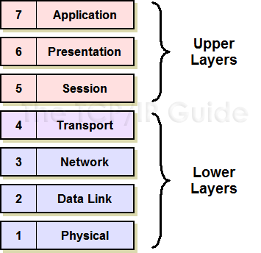
Figure 2. OSI Layers
3.0 TCP/IP MODEL
TCP (Transmission Control Protocol) /IP (Internet Protocol) was developed by the Department of Defense (DoD) project agency. Unlike OSI Model, it consists of four layers each having its own protocols. Internet Protocols are the set of rules defined for communication over the network.
TCP/IP is considered as a standard protocol model for networking. TCP handles data transmission and IP handles addresses. The TCP/IP protocol suite has a set of protocols that includes TCP, UDP, ARP, DNS, HTTP, ICMP, etc. It is a robust and flexible model. The TCP/IP model is mostly used for interconnecting computers over the internet.
3.1 History of TCP/IP
In 1974, Vint Cerf and Bob Kahn published a paper "A Protocol for Packet Network Interconnection" which describes the TCP/IP Model.
By 1978, testing and further development of this language led to a new suite of protocols called TCP/IP.
In 1982, it was decided that TCP/IP should be replaced NCP as the standard language of the ARPAnet.
On January 1, 1983, ARPAnet switched over to TCP/IP,
ARPAnet ceased to exist in 1990. The Internet has since grown from ARPAnet's roots, and TCP/IP evolved to meet the changing requirements of the Internet.

3.2 TCP/IP Model Layers
Network Interface Layer: This layer acts as an interface between hosts and transmission links and used for transmitting datagrams. It also specifies what operation must be performed by links like serial link and classic ethernet to fulfil the requirements of the connectionless internet layer.
Internet Layer: The purpose of this layer is to transmit an independent packet into any network which travels to the destination (might be residing in a different network). It includes the IP (Internet Protocol), ICMP (Internet Control Message Protocol) and ARP (Address Resolution Protocol) as the standard packet format for the layer.
Transport Layer: It enables a fault-free end-to-end delivery of the data between the source and destination hosts in the form of datagrams. The protocols defined by this layer are TCP (Transmission Control Protocol) and UDP (User Datagram Protocol).
Application Layer: This layer permits users to access the services of global or private internet. The various protocols described in this layer are virtual terminal (TELNET), electronic mail (SMTP) and file transfer (FTP). Some additional protocols like DNS (Domain Name System), HTTP (Hypertext Transfer Protocol) and RTP (Real-time Transport Protocol). The working of this layer is a combination of application, presentation and session layer of the OSI model.
4.0 COMPARISON BETWEEN TCP/IP AND OSI REFERENCE MODEL
Internet Protocol Suit (more commonly referred to as TCP/IP) was already on the path of development when the OSI standard architecture appeared and, strictly speaking, TCP/IP does not conform to the OSI model. However, the two models did have similar goals, and enough interaction occurred among the designers of these standards that they emerged with a certain compatibility. The OSI model has been very influential in the growth and development of protocol implementations, and it is quite common to see the OSI terminology applied to TCP/IP.
Figure 1 shows the relationship between the four-layer TCP/IP standard and the seven-layer OSI model. te that the OSI model divides the duties of the Application layer into three layers: Application, Presentation, and Session. OSI splits the activities of the Network Access layer into a Data Link layer and a Physical layer. This increased subdivision adds some complexity, but it also adds flexibility for developers by targeting the protocol layers to more specific services. In particular, the division at the lower level into the Data Link and Physical layers separates the functions related to organizing communication from the functions related to accessing the communication medium. The three upper OSI layers offer a greater variety of alternatives for an application to interface with the protocol stack.
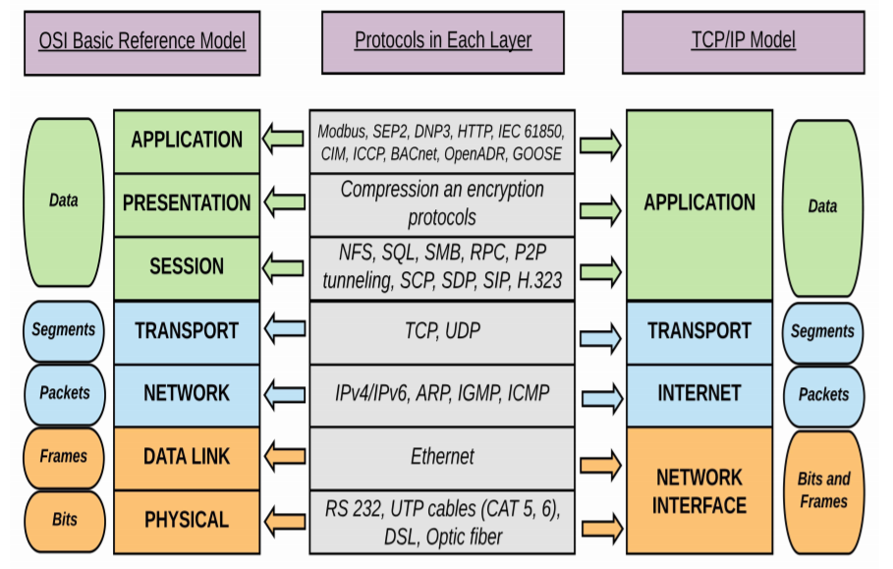
Figure 3. Comparison of layers in the OSI model.
It is important to remember that the TCP/IP model and the OSI model are standards, not implementations. Real-world implementations of TCP/IP do not always map cleanly to the models shown in Figure 3 and the perfect correspondence depicted in the figure is also a matter of some discussion within the industry.
Notice that the OSI and TCP/IP models are most similar at the important Transport and Internet (called Network in OSI) layers. These layers include the most identifiable and distinguishing components of the protocol system, and it is no coincidence that protocol systems are sometimes named for their Transport and Network layer protocols. As you learn later in this book, the TCP/IP protocol suite is named for TCP, a Transport layer protocol, and IP, an Internet/Network layer protocol.
4.1 Similarities and Differences between TCP/IP and OSI
Following are some similarities between OSI Reference Model and TCP/IP Reference Model.
- Both have layered architecture.
- Layers provide similar functionalities.
- Both are protocol stack.
- Both are reference models.

Table 2. Comparison of OSI and TCP/IP (1)
OSI | TCP/IP
1. OSI is a generic, protocol independent standard, acting as a communication gateway between the network and end user. | 1. TCP/IP model is based on standard protocols around which the Internet has developed. It is a communication protocol, which allows connection of hosts over a network.
2. In OSI model the transport layer guarantees the delivery of packets. | 2. In TCP/IP model the transport layer does not guarantee delivery of packets. Still the TCP/IP model is more reliable.
3. Follows vertical approach. | 3. Follows horizontal approach.
4. OSI model has a separate Presentation layer and Session layer. | 4. TCP/IP does not have a separate Presentation layer or Session layer.
5. Transport Layer is Connection Oriented. | 5. Transport Layer is both Connection Oriented and Connection less.
6. Network Layer is both Connection Oriented and Connection less. | 6. Network Layer is Connection less.
7. OSI is a reference model around which the networks are built. Generally it is used as a guidance tool. | 7. TCP/IP model is, in a way an implementation of the OSI model.
8. Protocols are hidden in OSI model and are easily replaced as the technology changes. | 8. In TCP/IP replacing protocol is not easy.
9. OSI model defines services, interfaces and protocols very clearly and makes clear distinction between them. It is protocol independent. | 9. In TCP/IP, services, interfaces and protocols are not clearly separated. It is also protocol dependent.
12. It has 7 layers, i.e physical, data link, network, transport, session, presentation and application | 12. It has 4 layers, i.e network interface, network, transport and application.

Table 3. Comparison of OSI and TCP/IP (2)
BASIS FOR COMPARISON | TCP/IP MODEL | OSI MODEL
Expands To | Transmission Control Protocol/ Internet Protocol | Open system Interconnect
Meaning | It is a client server model used for transmission of data over the internet. | It is a theoretical model which is used for computing system.
Number Of Layers | 4 Layers | 7 Layers
Developed by | Department of Defense (DoD) | ISO (International Standard Organization)
Tangible | Yes | No
Application | Widely used on the Internet | Used as a reference
Approach used | Horizontal approach | Vertical approach

